

7 January 2022

**Terra Industrial New Zealand Ltd**

PO Box 16 168

16 Branston Street, Hornby

Christchurch 8441, New Zealand

03 983 2333 Tel

www.TerraCat.co.nz

**Splitting XML Files**

1. Open the XML file in Notepad++
2. Save a duplicate of the file with a slightly different name
3. Find the halfway point in the first file. Best way to do this is:
   1. Scroll to the bottom of the file to find the number it ends at. In this instance it is 167017

* 1. Divide that number by 2. The result of this one is **83508**

1. Now that we have that divided result, we can go ahead and delete the second half of the file, making sure there are closing brackets at the end of the file, like in the image below. (Closing bracket is shown as **</text>** and an open bracket is shown as **<text>**)

1. Press **CTRL G** to open the search box
2. Type in your divided result, in this instance it was **83508**, press **ENTER**

1. You should be taken to that exact line

1. At the top, select **EDIT** then **BEGIN/END SELECT**

1. Press **CTRL G** to bring up the search box again
2. Type in the last number of the file that has **</Source-of-supply>,** in this instance it is **167016**, select **GO**

1. Go back up to **EDIT** and untick **BEGIN/END SELECT**

1. Your selection should now be highlighted, not including the source of supply line

1. Press **DELETE** – your highlighted selection should be removed, and the source of supply line should now be sitting on **83508** – the line from earlier.

1. Scroll to the top and double check that the opening brackets are still there, like in the image below

1. Now we need to remove the first half of the file in the second copy using similar steps.
2. Press **CTRL G** to open the search box
3. Type in the number of the first line that has the first part number, in this instance it is **5**

1. Click **EDIT** at the top, select **BEGIN/END SELECT**

1. Press **CTRL G** to bring up the search box again
2. Type in the halfway point number again from earlier (**83508**) click **GO**

1. Click **EDIT** and unselect **BEGIN/END SELECT**

1. Your selected fields should now be highlighted like below

1. Press **DELETE**
2. Your selection should then be removed
3. Double check both files that the last part number from the first file isn’t the same as the first part number in the second file, if they are different then the selection was correct, like below

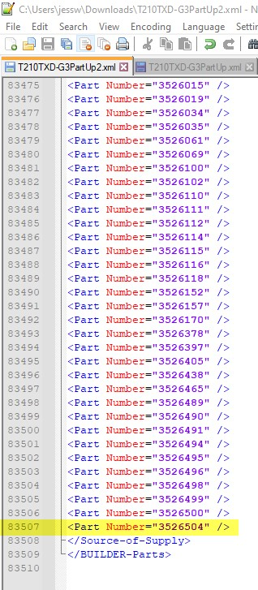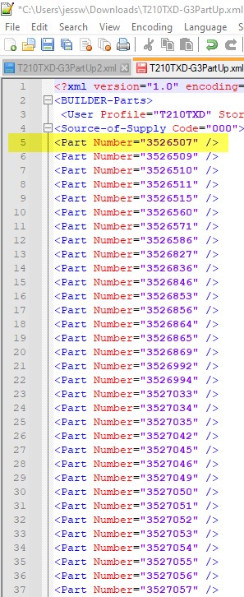

1. Now you have your split file, just need to save both